Calculus 1 Lecture 4.2: Integration by Substitution

Steps
- Pick “u” so the integral is easier.
Usually the inside of something,
The derivative of “u” must be in the integral
- Transform 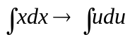
- Solve integral
- Translate back to “x”

Example
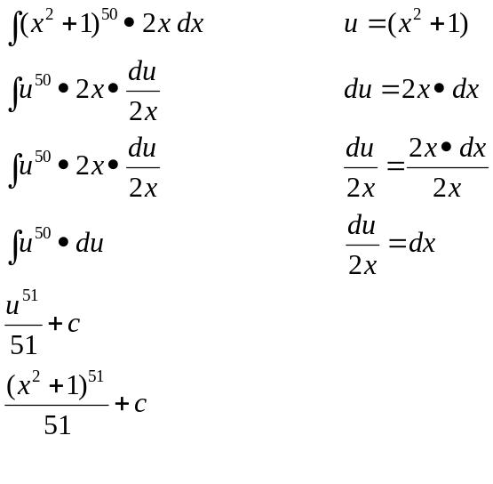

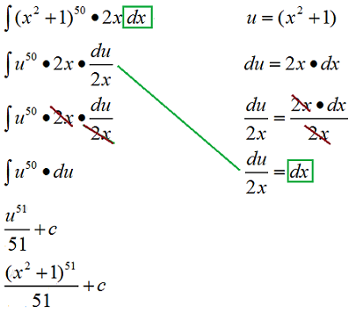

NOTE: All x’s must be eliminated.

Example
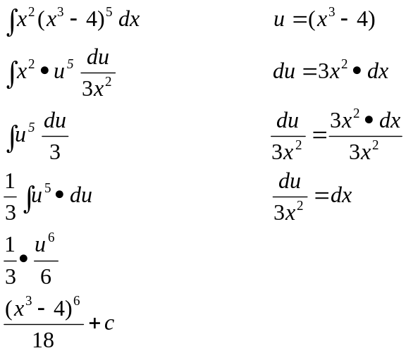

Example
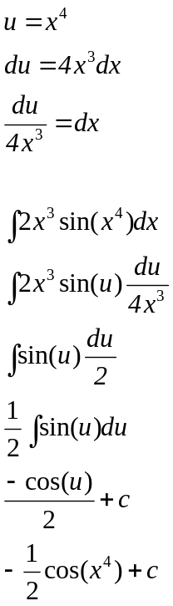

Example
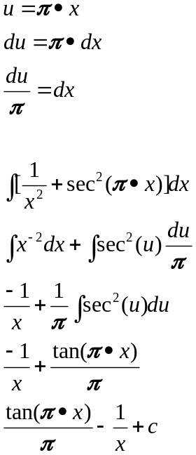

Example
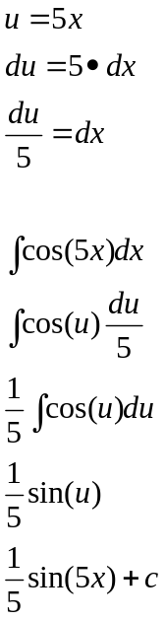

Example
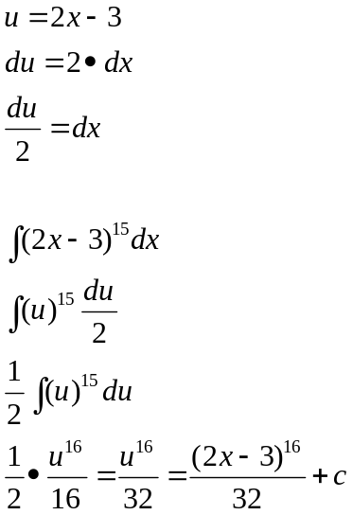

Example
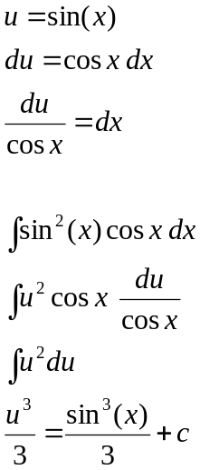

Example
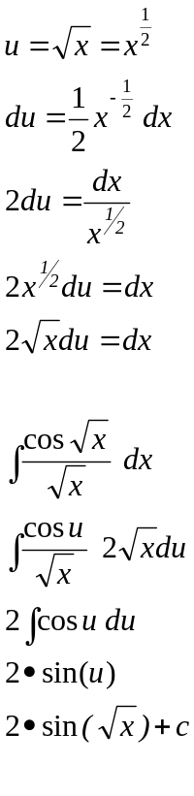

Example
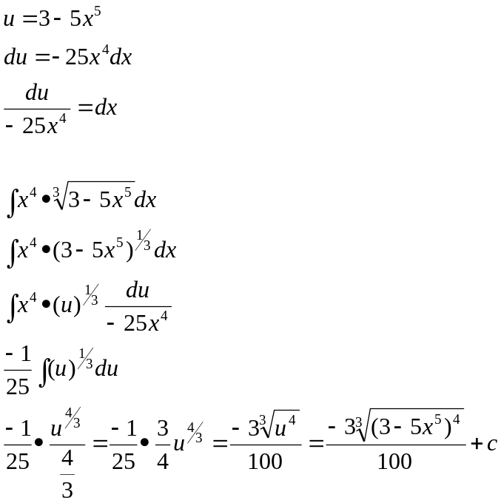

Example
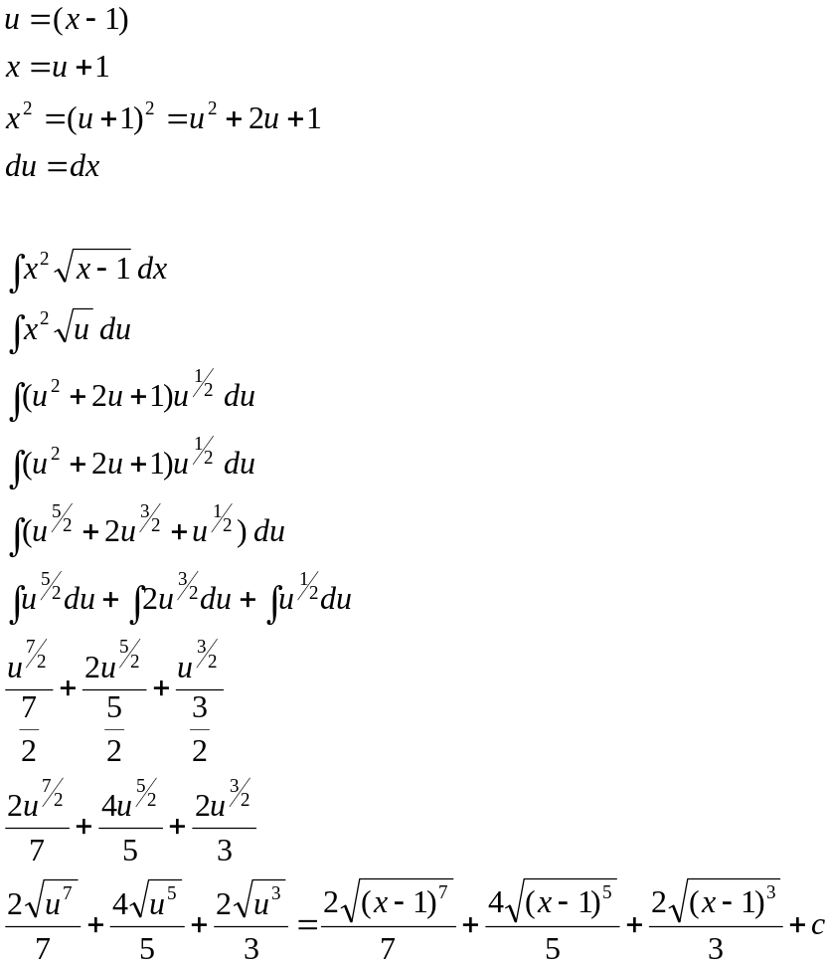

Example
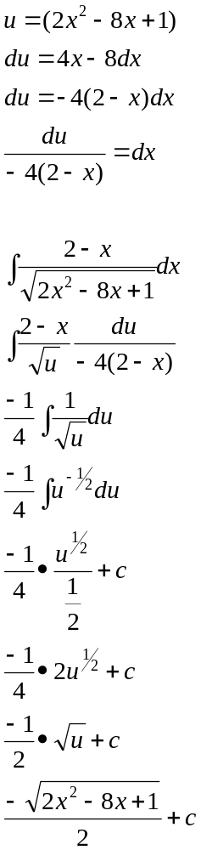

Example
